**User Activity**

**Steps to run the User Activity Project**

**Step1:-**

Install Postgre SQL - <https://www.enterprisedb.com/downloads/postgres-postgresql-downloads>.

**Step2:-**

Download project from github - <https://github.com/mohandash005/UserActivity>

**Step3:-**

Create one Database in Postgre SQL and add username, password & database name inside project (User Activity) settings file.

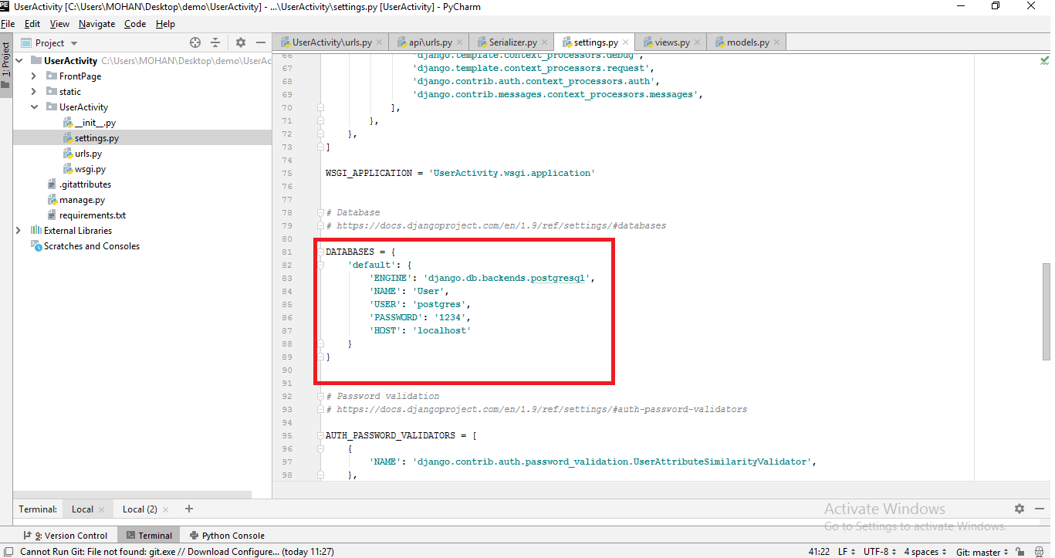

**Step4:-**

Open requirements.txt file to install all django packages

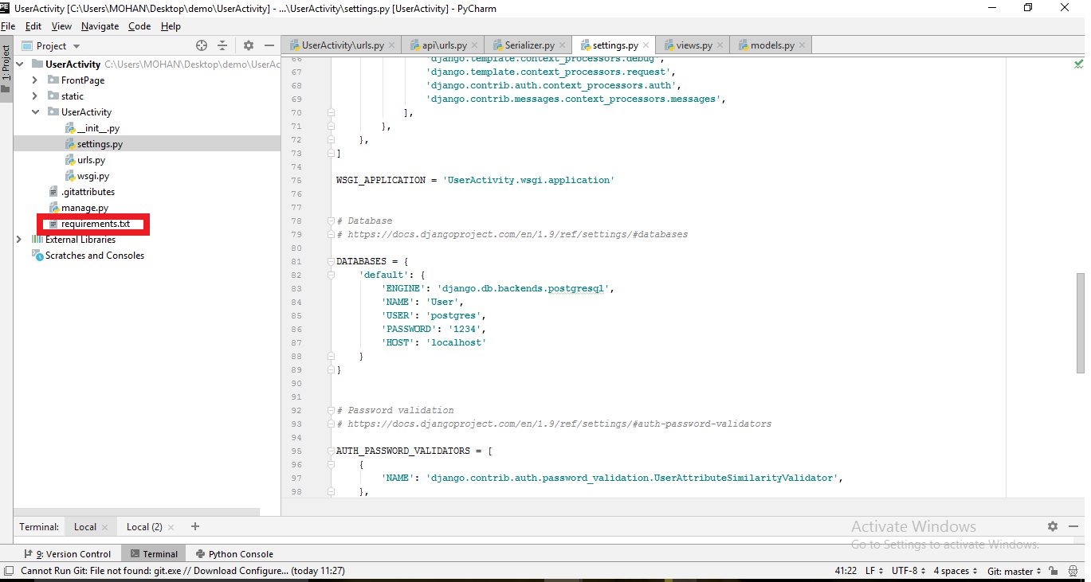

**Step5:-**

Run the cli for database migration

* Python manage.py makemigrations
* Python manage.py migrate

**Step6:-**

Run the application using cli

* Python manage.py runserver

Then click on Register to add some data after that click on Login with same mail address and password to navigate home page.

* For Login Page: <http://127.0.0.1:8000/Login>
* For Register Page: <http://127.0.0.1:8000/Sign>

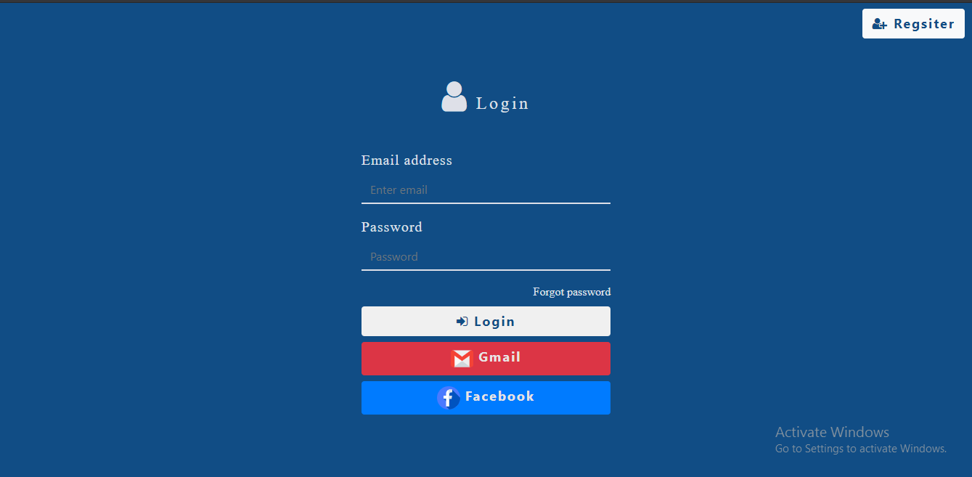

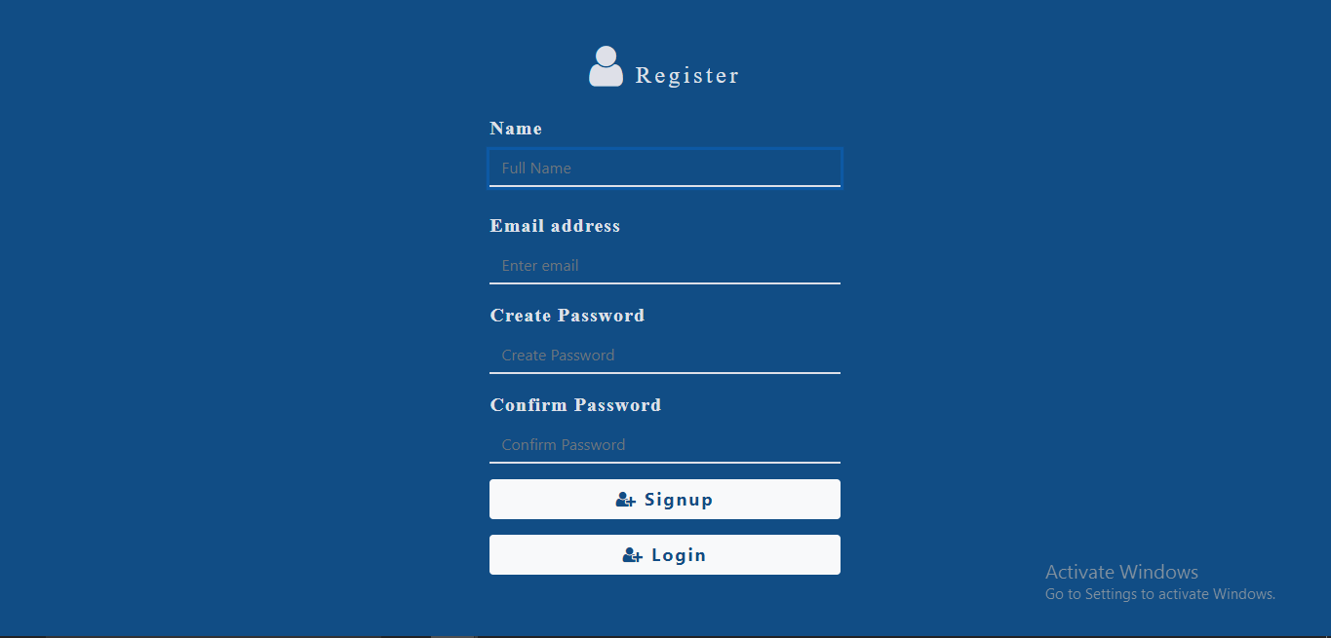

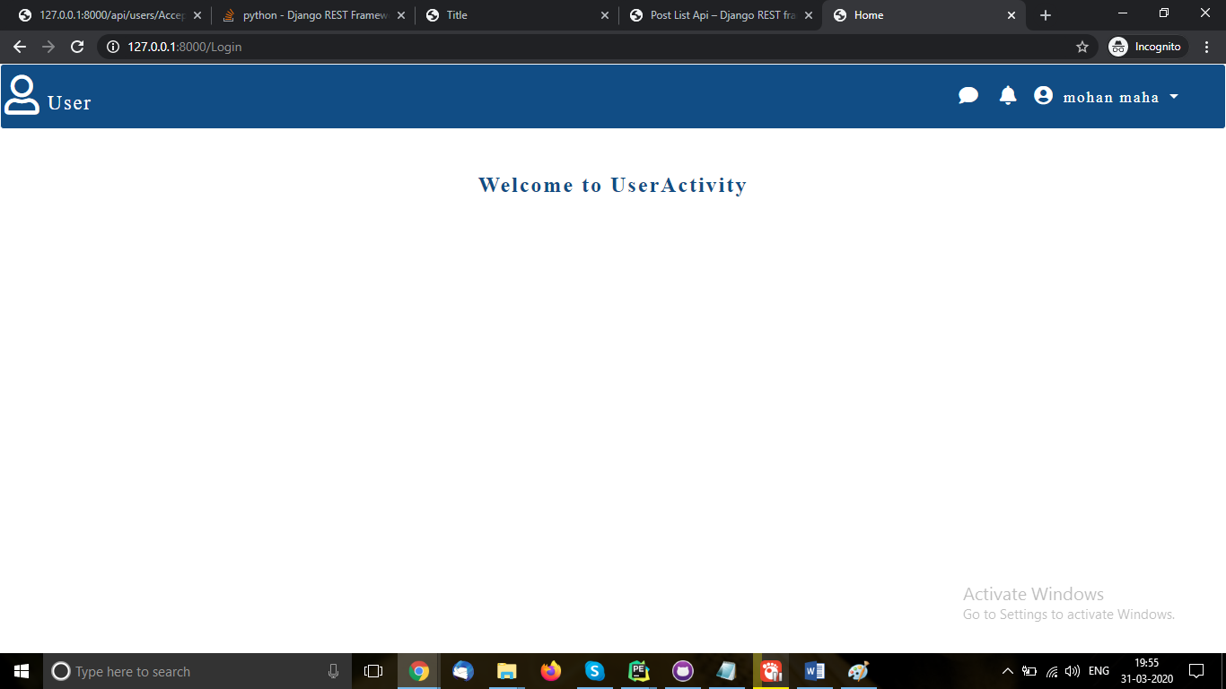

For Rest API: <http://127.0.0.1:8000/api/users/Accept:application/json?format=json>

